Task A – Design a five-page website

1. Prior to designing your website, it is important that you understand exactly what is required.

Firstly, you need to interview the head of marketing for Paws for Thought Pet Store, you will need to gain the following information from the interview:

* the aim and content of the website;
* any user requirements;
* timescales for completing the website;

Once you have this information you will need to produce a short plan that outlines the details you have learned.

Task A Answer

About the company:

Paws for Thought Pet Store in business for over 15 years and all their clients are recurrent customers or coming from word of mouth promotion. There is no online presence, except for a Facebook page which is in infancy and not very engaging.

**The goals of this website are:**

• Promote their shop and their products online;

• Attracting customers to visit their shop;

The shop needs a simple static 5 pages website, to highlight the following:

* 10 categories of products they offer and to show the best seller in each category;
* Services they offer: Grooming, Boarding and Dietician & Nutrition;
* A brief history of the company and profiles of the team members;
* A video and images about the shop, products and services they offer;
* Display a link to their Facebook page, so the customers can stay engaged and keep and eye on any updates;
* Location and address of the shop;
* Contact details: email address and phone number;
* Opening hours;

Considering the budget and time constraints, there will be no e-commerce function implemented. However, for an easy access and communication, the customers can click on a product and service to link to an automatic email completed with the details of the product/service they are interested in.

Their main competitor “Dogs Heaven” have already an amazing website, which will be a source of inspiration.

Colour scheme: blue and orange to be consistent with their front shop.

Budget: 1000 euros

Time allocated for completion: 2 weeks.

1. The head of marketing has asked you to design a five-page website that advertises Paws for thought to clients. The designs need to show the following:

* layout of each page -> see Index 1 wireframes; at the end of document
* a navigation diagram/storyboard -> see Index 2 sitemap at the end of the document
* the format of content including CSS –> see Index 1 wireframes; at the end of document
* any interactive features –> see Index 1 wireframes; at the end of document
* an email link for enquiries –> on Contact page, Products page and Services page – the buttons and the email address link to the email address of the shop;
* images – various images on the site -> see Index 1 wireframes; at the end of document;
* any animation –> see Index 1 wireframes; at the end of document

Task B – Build a functioning five page website

1. Using the plans created in Task A, build a functional five-page website that promotes Paws for Thought Pet Store.

Ensure your finished website includes the following:

* five functional pages – Links below are clickable to check the pages

[HOME Page](https://andreeaiosip.github.io/pet-shop/index.html)

[ABOUT Page](https://andreeaiosip.github.io/pet-shop/about.html)

[SERVICES Page](https://andreeaiosip.github.io/pet-shop/services.html)

[PRODUCTS Page](https://andreeaiosip.github.io/pet-shop/products.html)

[CONTACT Page](https://andreeaiosip.github.io/pet-shop/contact.html)

* any images
* Various images used in a photo carousel on the HOME Page, PRODUCTS Page and SERVICES Page
* navigation between each page
* navigation is working 100% between all pages – please see Index 3 - TESTING at the end of the Documentation.
* two interactive features

1. carousel of pictures on the HOME Page where the user can click on the arrows and move to the next picture
2. buttons on each product and service are linked to open a prefilled email with the appropriate subject line and body text to be sent to the email address of the shop
3. Google Map can be clicked, zoomed in and out

* one animation

1. photo carousel on the home page is set as automatic slideshow
2. navbar underlines the links when hovered
3. “Enquire” and “Order” buttons when hovered change the shade of blue colour

Task C – Test a functioning five-page website

1. Now that your website is complete, ask the assessor to observe you whilst you complete the following tests:

* functionality testing, open your website in two different web browsers
* test your navigation, demonstrating the functionality of each link
* test your interactive features

I have tested the website on Chrome and Firefox browsers. Please see below a list of tests I have performed and the outcome.

To check if the website is responsive, I have used Google Chrome and Firefox Dev Tools. I have also used [www.responsinator.com](http://www.responsinator.com) and you can see [HERE](http://www.responsinator.com/?url=https%3A%2F%2Fandreeaiosip.github.io%2Fpet-shop%2Findex.html) the results and how the website looks like on various screens.

INDEX 1

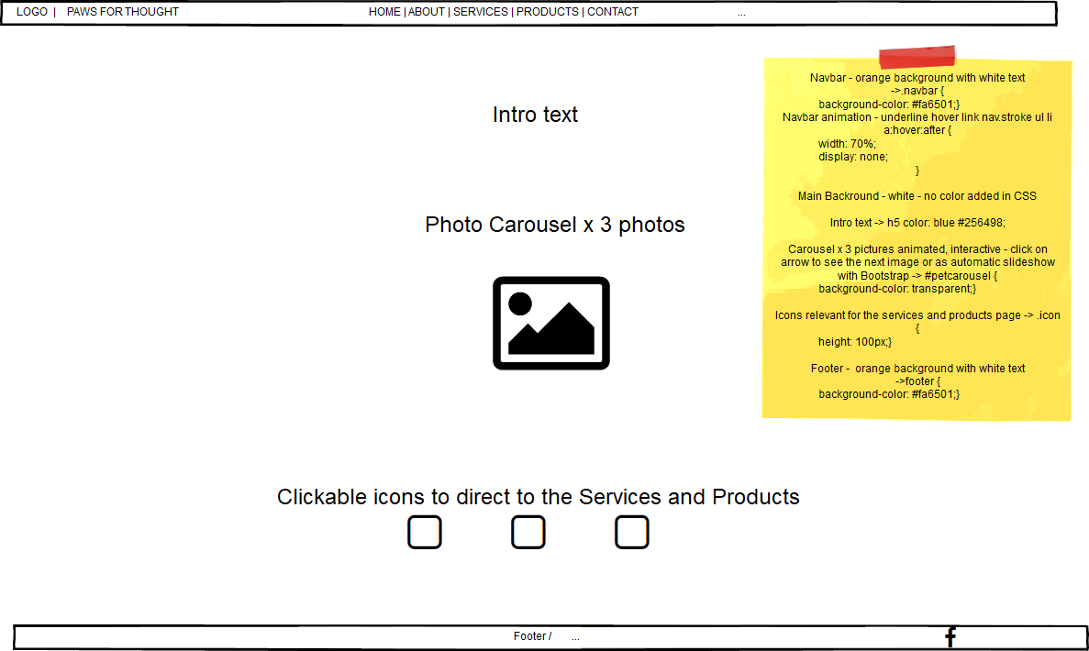HOME PAGE

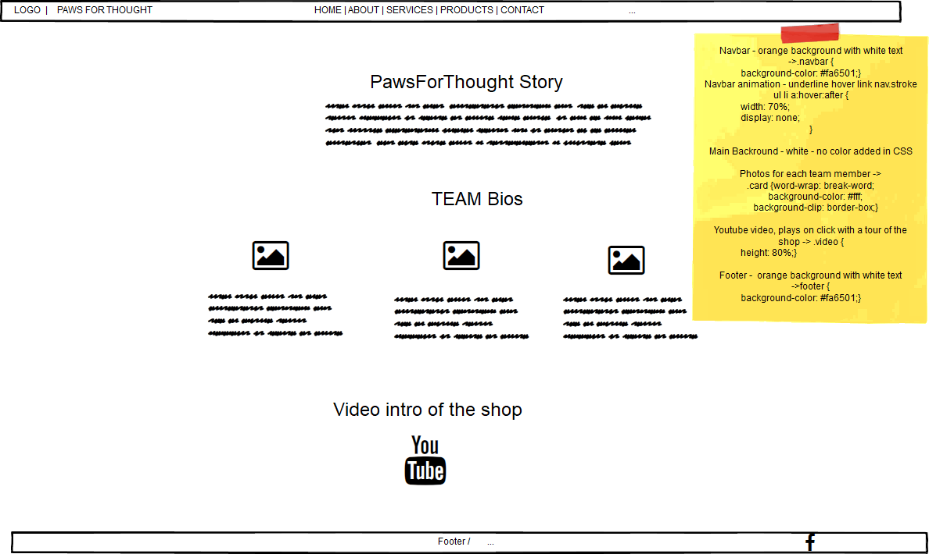ABOUT PAGE

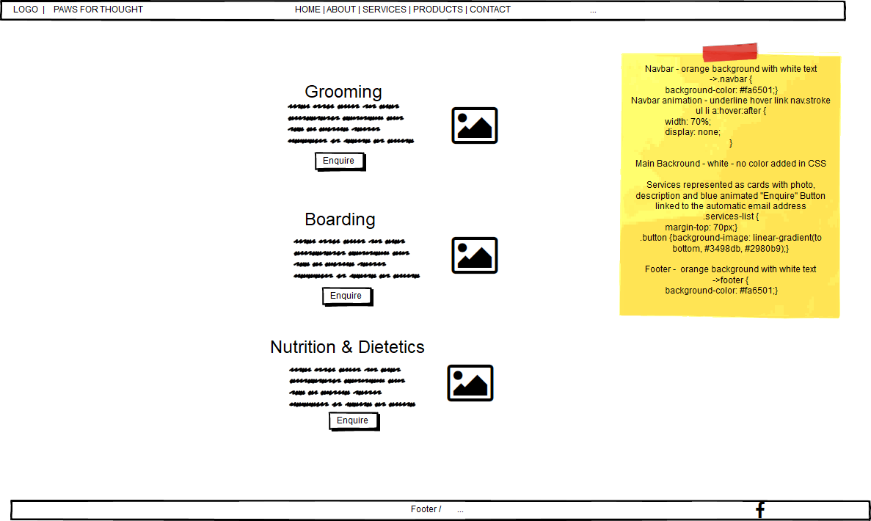SERVICES

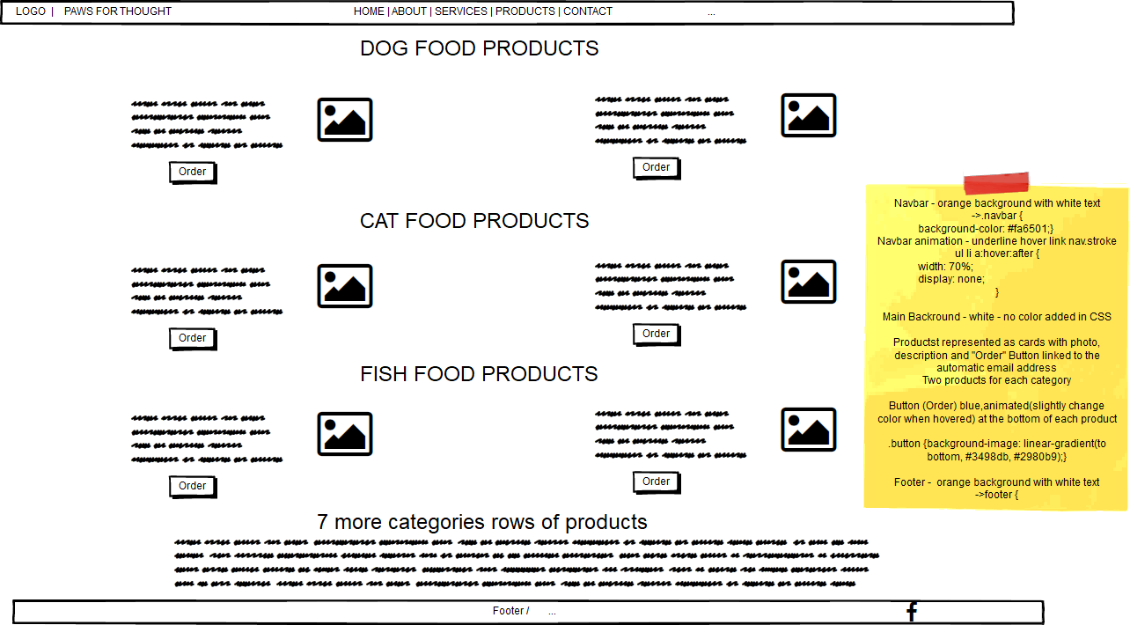PRODUCTS

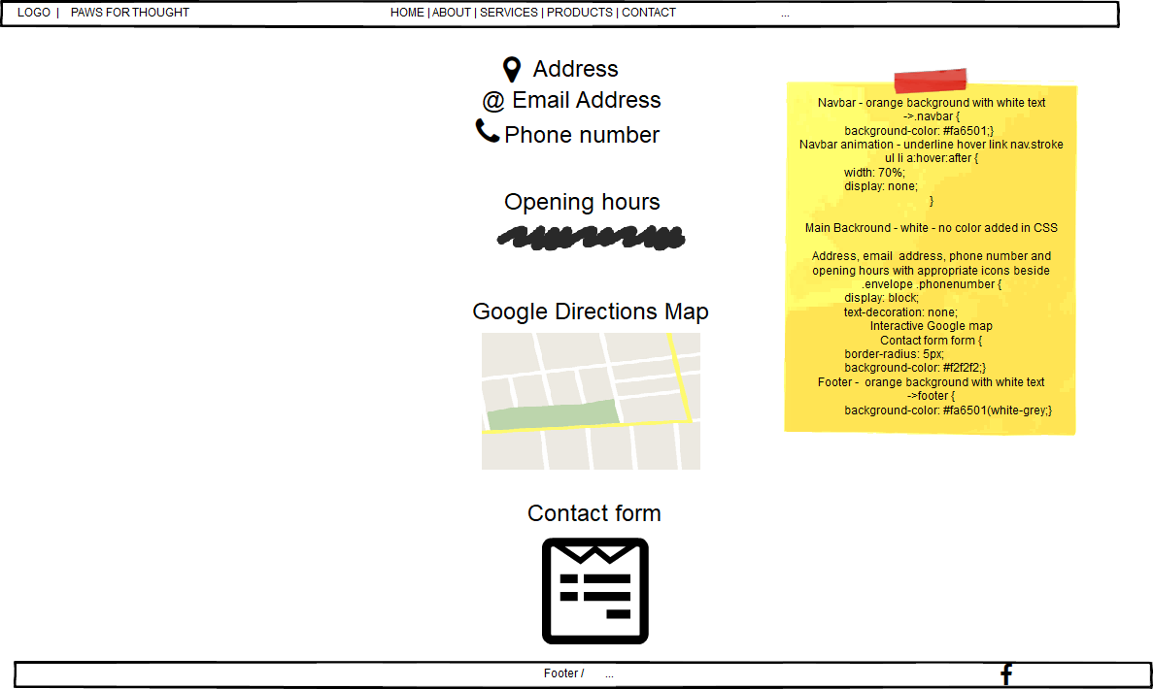CONTACT

Task D – Knowledge

1. Describe three hardware and three software components that enable access to the web.
2. Explain the role of the following protocols:

* TCP/IP including IPv6
* HTTP
* SMTP

1. Explain the role of the following:

* Internet Service Provider
* Domain name registrar
* Web hosting service

1. Identify and briefly describe four types of web functionality.
2. Explain the use of two different Mark-Up languages.
3. Explain the use and functionality of:

* Web runtime environments
* Web application programming languages
* Databases including SQL
* PHP

1. Identify one typical stack combination that can be used for web development.